**Storyboard**

A storyboard is a visual tool for exploring how an example user experiences a product. In a storyboard, a designer visually displays the process that a user may undergo in order to accomplish a goal. The process is called a user journey. Storyboards and user journeys help product designers, engineers, and managers understand how users may interact with their products which, in turn, helps designers create more human-centered products.

Example

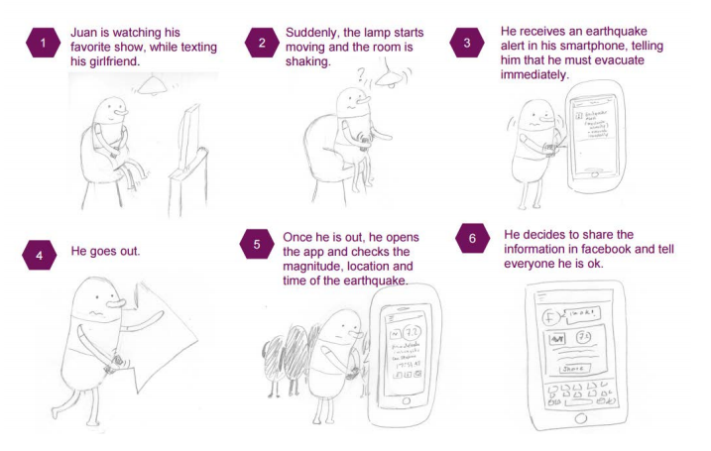

reference: https://medium.com/codingurukul/user-journey-scenarios-storyboards-and-flows-understanding-your-users-f98c8ff871f3